Amorphous Icy Particles

# Summary

Hexagonal samples (but smaller crystallites than for LN2 spraying).

Smooth D2O surfaces.

Ethane admixtures with diffuse surfaces at T < 140 K.

# Limitations

Very poor statistics prevent in-depth analysis of structure both for low-Q and high-Q ranges.

Ethane admixtures further complicate analysis.

# Samples

|  |  |  |  |  |  |
| --- | --- | --- | --- | --- | --- |
| Date of production | Sample | Ethane T range | Aspirator purge pressure  (above atmospheric P) | Net D2O spraying time | Transfer time (extraction from ethane to plunge into LN2) |
| 03/05/18  (night) | 1  non-crystalline  no notes taken, all from memory |  | Best guess 200 mbar | Approx. 10 min | No notes taken |
| 05/05/18 | 2  hexagonal  potential contamination from ice frozen on nozzle | -125 to –100 C  (approx.  148 to 173 K) | 150 mbar | Approx. 20 min | Vincent  Guess : longer than usual (more than 10s) |
| 06/05/18 | 3  non-crystalline | -166 to -135 C  (approx.  107 to 138 K) | 200 mbar | Approx. 30 min | Vincent  Guess: not long but particles still submerged by ethane |
| 08/05/18  (afternoon) | 4  hexagonal | -149 to -124 C  (approx.  124 to 149 K) | 500 – 600 mbar | Approx. 30 min | Vincent  Normal (5s) |
| Sabrina  14/05/18  10:11 | Note:  Sample 4 was scratched out of the basket strainer using a wooden stick rather than a spatula. Splinters of wood were left in the funnel after the filling procedure. We don’t know if (or how much) wood got into the sample can. | | | | |

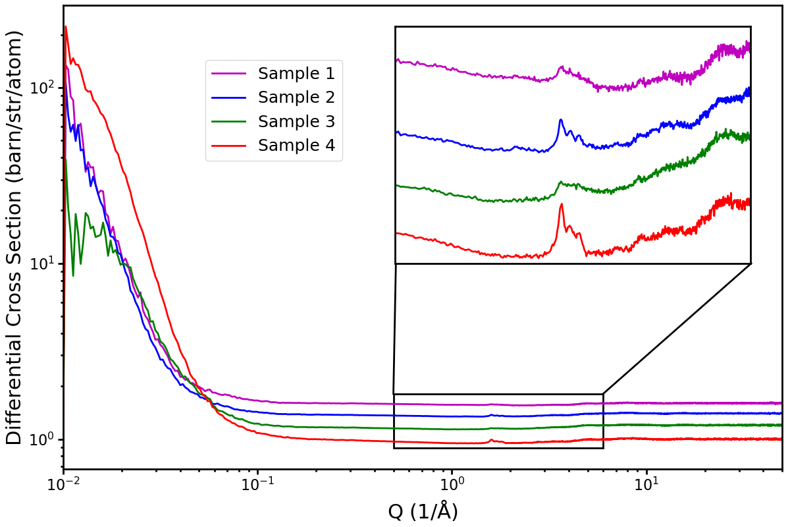

# Gudrun Analysis

We know from preliminary analysis at ISIS that all samples contained ethane at low temperatures, which appears to have evaporated by 140 K.

In addition, we got very little D2O into the sample cans; high T tweak factors come out around 30 to 80, final weighing of the cans came out around tweak factors of 90.

To improve statistics, I followed Tom’s advice to do a moving average. I processed data from across two isothermal points and half of the adjacent heating ramps together in Gudrun. This window was moved one isothermal point at a time. The only exception being sample 1, where data was collected for 2 h at a lower number of isothermal points. Here I processed the initial heating ramp leading to an isothermal step together with that step.

To determine the amount of ethane, I initially processed the data using a pure D2O sample composition. I fitted the tweak factors at T > 140 K as a function of T and extrapolated that function to low T to determine the likely water amount in the system. I then added ethane to the system and looped to adjust the ethane amount, keeping the water amount fixed, until DCS match was achieved. (I.e. the scattering background seen at high Q matches that expected for the given sample composition.)

The results of this analysis are plotted below.

## Moving Average

|  |  |
| --- | --- |
| Sample 1 | Sample 3 |
| C:\Users\mwx82498\AppData\Local\Microsoft\Windows\INetCache\Content.Word\sample_1_ethane_amount_moving_average_files_vs_time.png | C:\Users\mwx82498\AppData\Local\Microsoft\Windows\INetCache\Content.Word\sample_3_ethane_amount_moving_average_files_vs_time.png |
| Sample 2 | Sample 4 |
| C:\Users\mwx82498\AppData\Local\Microsoft\Windows\INetCache\Content.Word\sample_2_ethane_amount_moving_average_files_vs_time.png | C:\Users\mwx82498\AppData\Local\Microsoft\Windows\INetCache\Content.Word\sample_4_ethane_amount_moving_average_files_vs_time.png |

## Tweak Factors

|  |  |
| --- | --- |
| Blue: D2O, Black: whole sample |  |
| Sample 1 | Sample 3 |
| C:\Users\mwx82498\AppData\Local\Microsoft\Windows\INetCache\Content.Word\sample_1_ethane_amount_moving_average_tweak_factors.png | C:\Users\mwx82498\AppData\Local\Microsoft\Windows\INetCache\Content.Word\sample_3_ethane_amount_moving_average_tweak_factors.png |
| Sample 2 | Sample 4 |
| C:\Users\mwx82498\AppData\Local\Microsoft\Windows\INetCache\Content.Word\sample_2_ethane_amount_moving_average_tweak_factors.png | C:\Users\mwx82498\AppData\Local\Microsoft\Windows\INetCache\Content.Word\sample_4_ethane_amount_moving_average_tweak_factors.png |

## Ethane Amounts

|  |  |
| --- | --- |
| Sample 1 | Sample 3 |
| C:\Users\mwx82498\AppData\Local\Microsoft\Windows\INetCache\Content.Word\sample_1_ethane_amount_moving_average_ethane_water_ratio.png | C:\Users\mwx82498\AppData\Local\Microsoft\Windows\INetCache\Content.Word\sample_3_ethane_amount_moving_average_ethane_water_ratio.png |
| Sample 2 | Sample 4 |
| C:\Users\mwx82498\AppData\Local\Microsoft\Windows\INetCache\Content.Word\sample_2_ethane_amount_moving_average_ethane_water_ratio.png | C:\Users\mwx82498\AppData\Local\Microsoft\Windows\INetCache\Content.Word\sample_4_ethane_amount_moving_average_ethane_water_ratio.png |

## Data & Uncertainties

### Sample 1

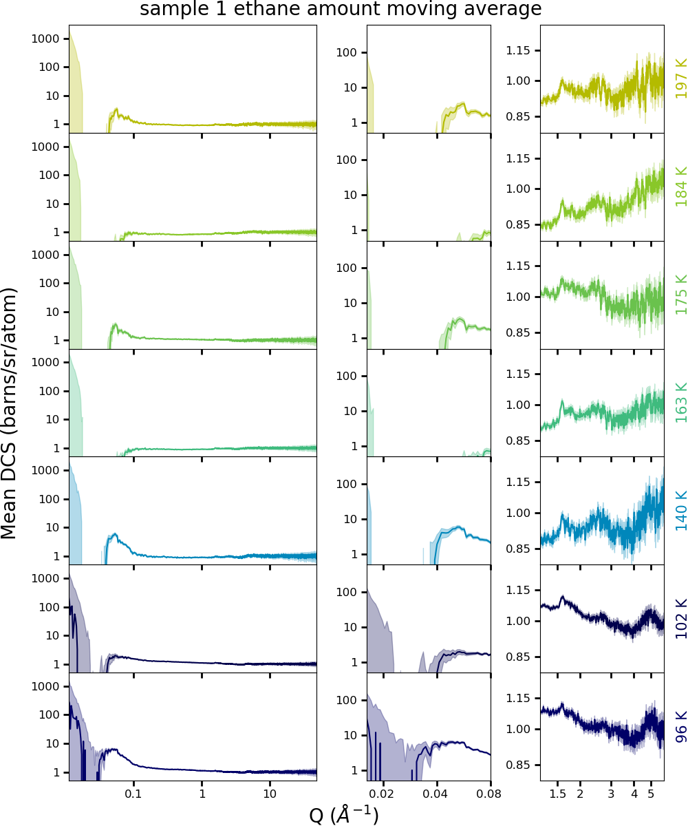

### Sample 2

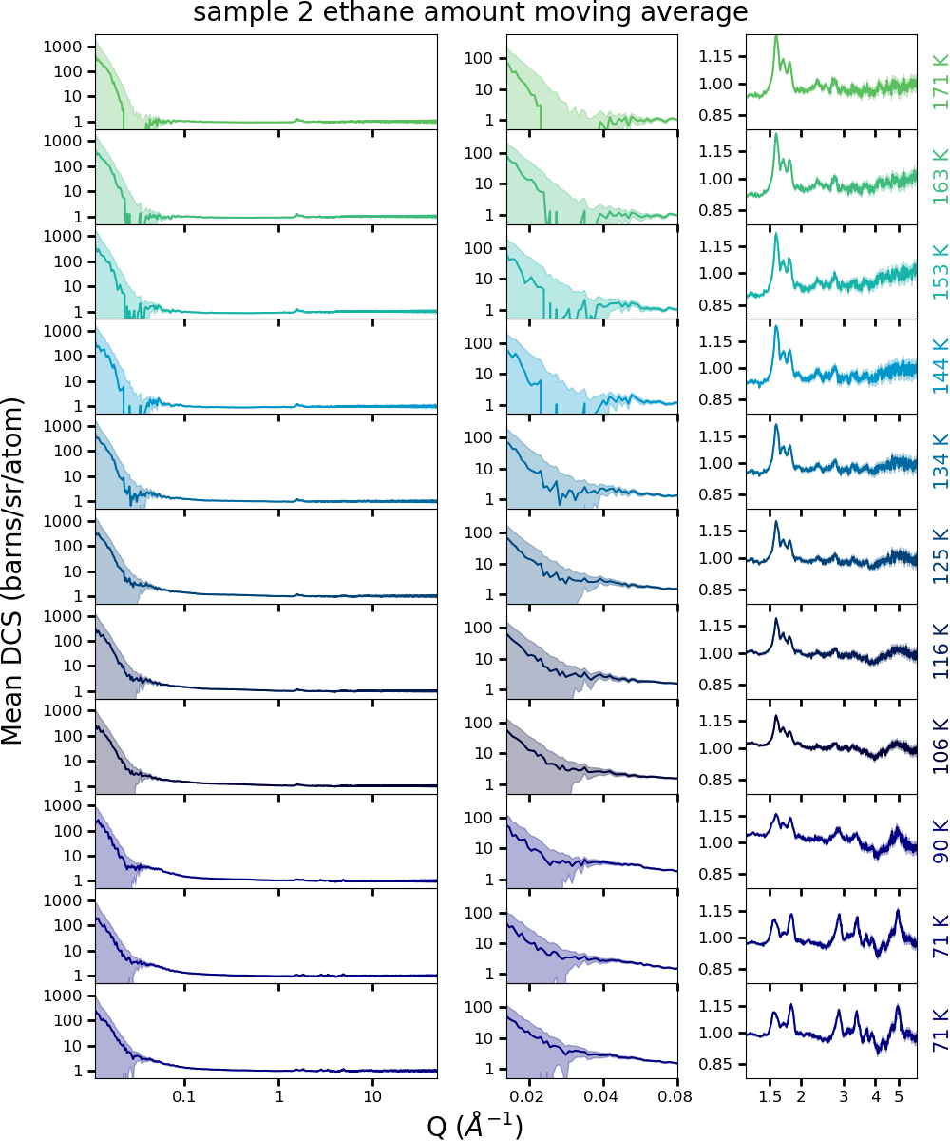

### Sample 3

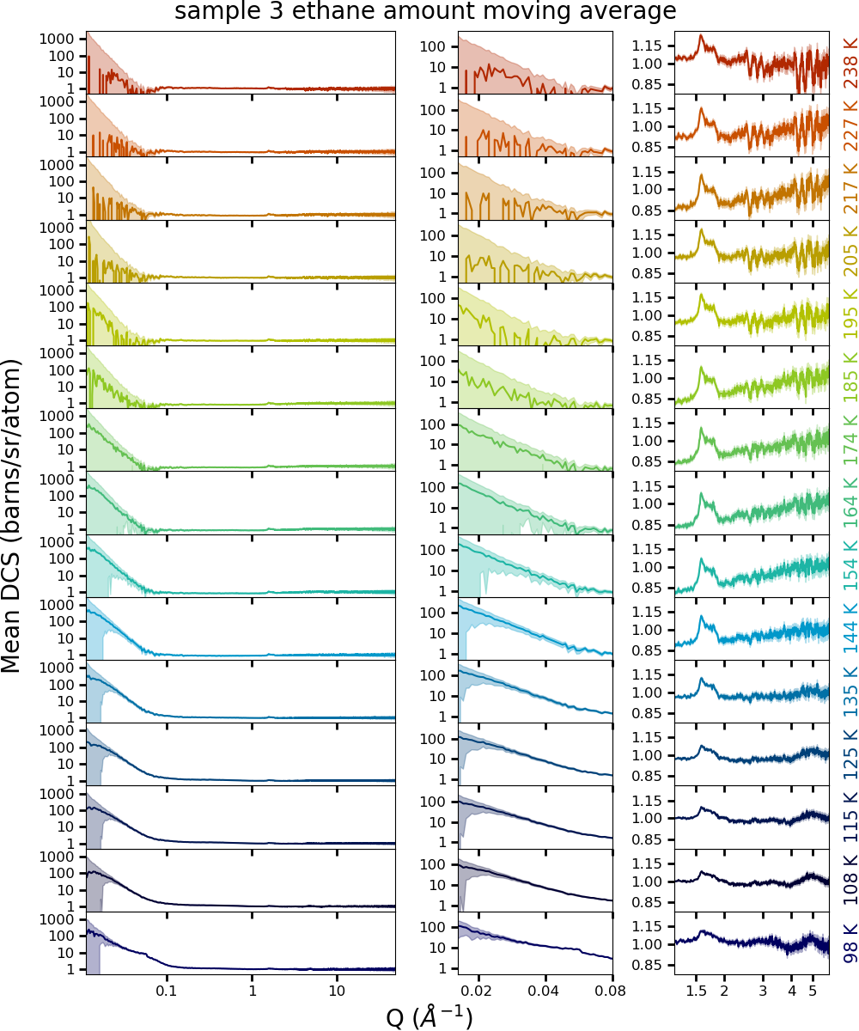

### Sample 4

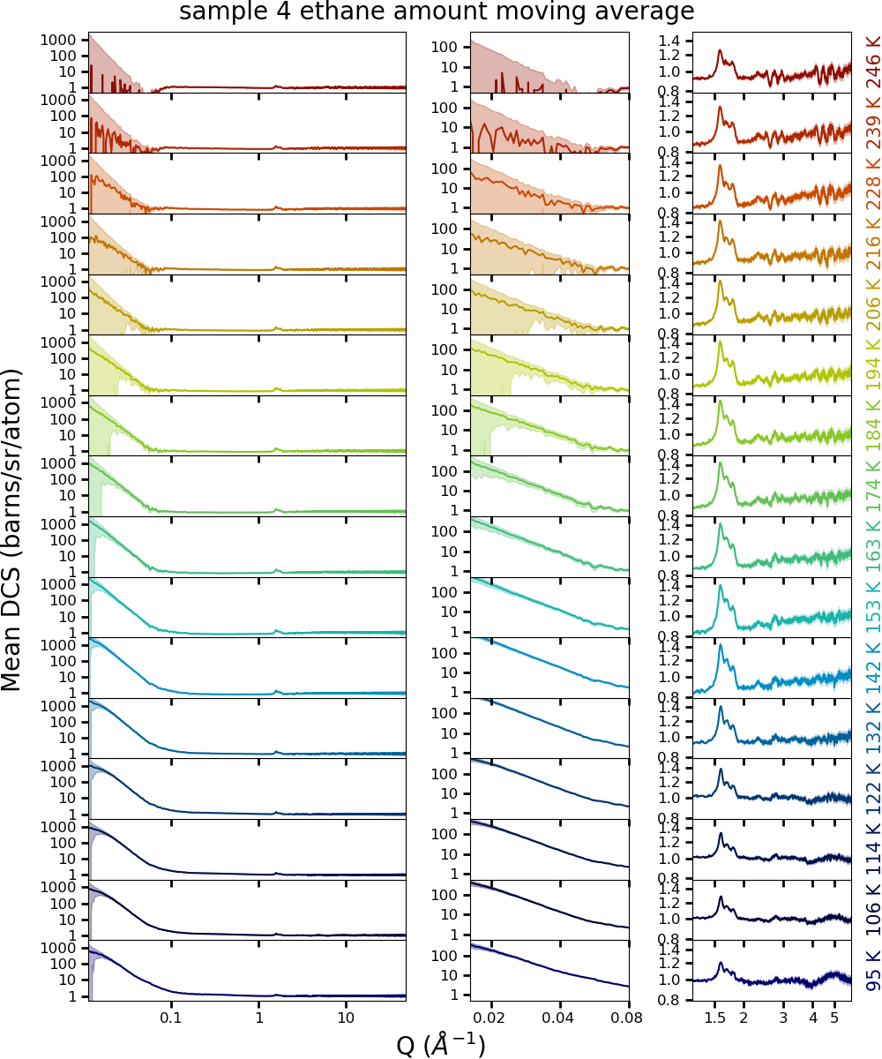

## DCS All Samples

The plots below show all temperature points for each sample. The black labels on the colour bar are the mean temperatures of the according dataset. The colourful temperature labels are “sample” labels for data handling and can be ignored.

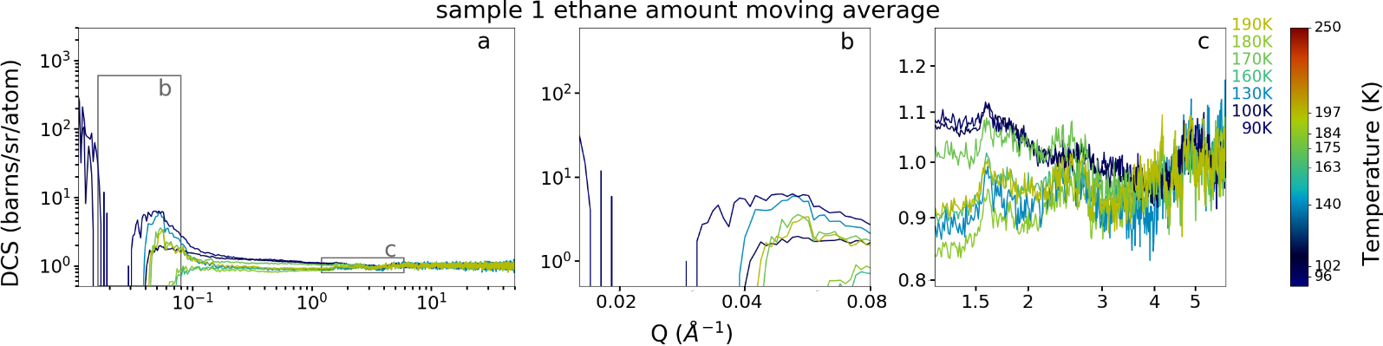

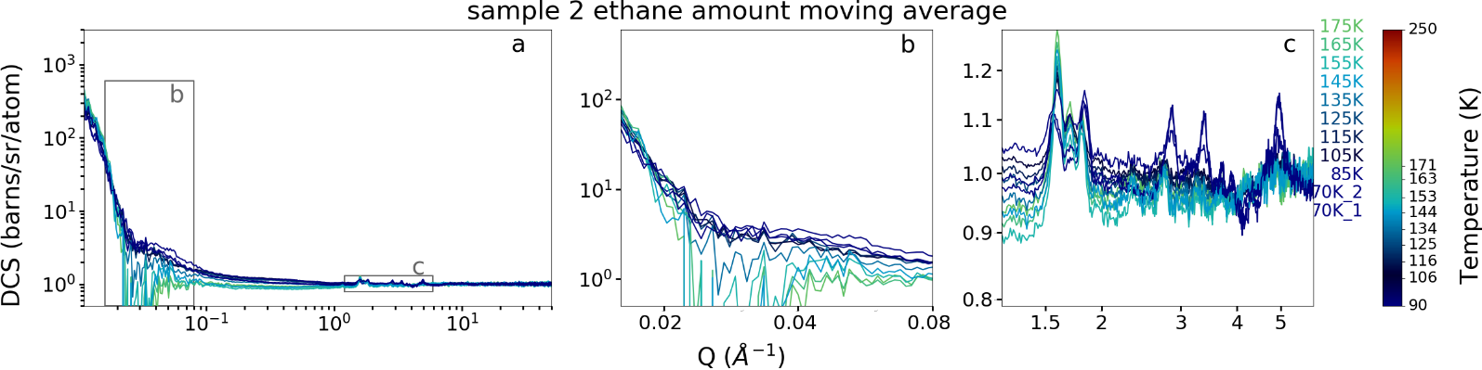

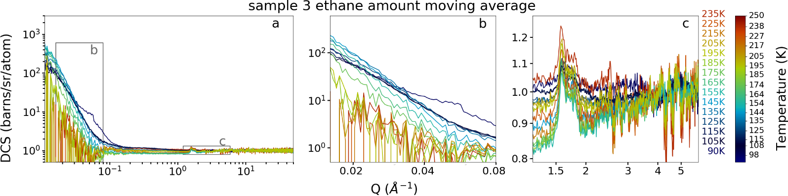

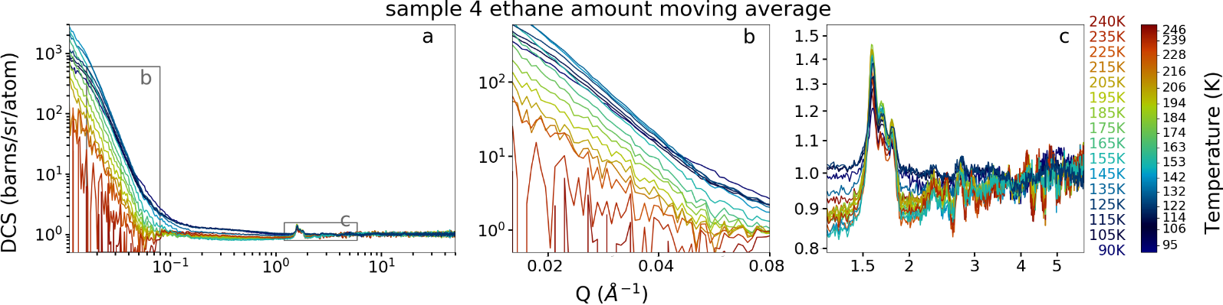

# Ice Phase

The analysis presented here follows the same method used for the icy particles that were sprayed into LN2.

I used the same peak positions, widths, and relative intensities, scaling the total amount of each ice phase to match the observed diffraction pattern by summing different ice phases.

The absolute amounts for the respective ice phases come out lower than for the icy particles, the relative amounts point to a higher fraction of Ih.

I believe, together this means still hexagonal ice, but smaller crystallites. (Interestingly, only sample 4 fits better when Ic is introduced – and requires only tiny amounts and only in the intermediate T-range.)

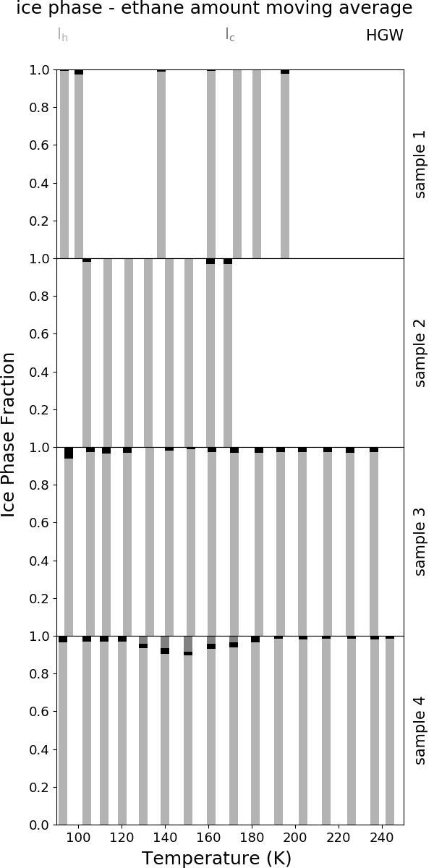

## Sample 1

|  |  |  |
| --- | --- | --- |
|  |  |  |
|  |  |  |
|  |  |  |

## Sample 2

|  |  |  |
| --- | --- | --- |
|  |  |  |
|  |  |  |
|  |  |  |
|  |  |  |

## Sample 3

|  |  |  |
| --- | --- | --- |
|  |  |  |
|  |  |  |
|  |  |  |
|  |  |  |
|  |  |  |

## Sample 4

|  |  |  |
| --- | --- | --- |
| C:\Users\mwx82498\AppData\Local\Microsoft\Windows\INetCache\Content.Word\peak_fit_NIMROD00056622.png | C:\Users\mwx82498\AppData\Local\Microsoft\Windows\INetCache\Content.Word\peak_fit_NIMROD00056688.png | C:\Users\mwx82498\AppData\Local\Microsoft\Windows\INetCache\Content.Word\peak_fit_NIMROD00056767.png |
| C:\Users\mwx82498\AppData\Local\Microsoft\Windows\INetCache\Content.Word\peak_fit_NIMROD00056630.png | C:\Users\mwx82498\AppData\Local\Microsoft\Windows\INetCache\Content.Word\peak_fit_NIMROD00056701.png | C:\Users\mwx82498\AppData\Local\Microsoft\Windows\INetCache\Content.Word\peak_fit_NIMROD00056781.png |
| peak_fit_NIMROD00056638 | C:\Users\mwx82498\AppData\Local\Microsoft\Windows\INetCache\Content.Word\peak_fit_NIMROD00056714.png | C:\Users\mwx82498\AppData\Local\Microsoft\Windows\INetCache\Content.Word\peak_fit_NIMROD00056793.png |
| peak_fit_NIMROD00056651 | C:\Users\mwx82498\AppData\Local\Microsoft\Windows\INetCache\Content.Word\peak_fit_NIMROD00056727.png | C:\Users\mwx82498\AppData\Local\Microsoft\Windows\INetCache\Content.Word\peak_fit_NIMROD00056816.png |
| peak_fit_NIMROD00056663 | C:\Users\mwx82498\AppData\Local\Microsoft\Windows\INetCache\Content.Word\peak_fit_NIMROD00056740.png |  |
| C:\Users\mwx82498\AppData\Local\Microsoft\Windows\INetCache\Content.Word\peak_fit_NIMROD00056675.png | C:\Users\mwx82498\AppData\Local\Microsoft\Windows\INetCache\Content.Word\peak_fit_NIMROD00056753.png |  |

# Surface – Porod Analysis

Strickly speaking, we have a three component system: D2O, C2H6, and He. We therefore may have the following interface types: D2O – He (abbreviated DH), D2O – C2H6 (abbreviated DC), and C2H6 – He (abbreviated CH).

The low-Q signal is thus given by the sum of three Porod terms, one for each interface type:

$$I\left(Q\right)= offset+2π\sum_{i}{{\left(∆ρ_{i}\right)}^{2}∙{SSA}_{i}∙Q^{-d_{i}}} , i=DH, DC, CH$$

$${\left(∆ρ_{CH}\right)}^{2}=3.4 ×{10}^{-12} Å^{-4}$$

$${\left(∆ρ_{DH}\right)}^{2}=33.2 ×{10}^{-12} Å^{-4}$$

$${\left(∆ρ_{DC}\right)}^{2}=57.6 ×{10}^{-12} Å^{-4}$$

This function has too many parameters, so no fitting attempt converged. I have instead fitted a simple Porod function:

$$I\left(Q\right)= offset+2π∙{\left(∆ρ\right)}^{2}∙SSA∙Q^{-d}$$

This assumes that all interfaces have the same structure, hence the same d-parameter. Based on that assumption, the total contrast ${\left(∆ρ\right)}^{2}$ will be a weighted sum of the individual contrasts for each interface type, as shown in the plot below.

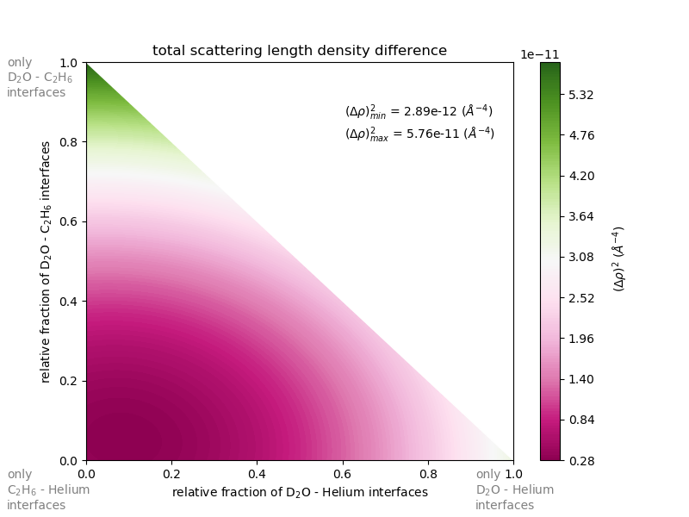

The derived SSA depends on the value chosen for the contrast. I have chosen that to be the contrast of D2O, meaning that at high T, where ethane is gone, the derived SSA will be meaningful.

I have run the analysis on all 4 samples, although samples 1 and 2 show too few signal at low-Q to allow reliable fitting at any temperature. See raw data plots.

## Raw Data – Low-Q

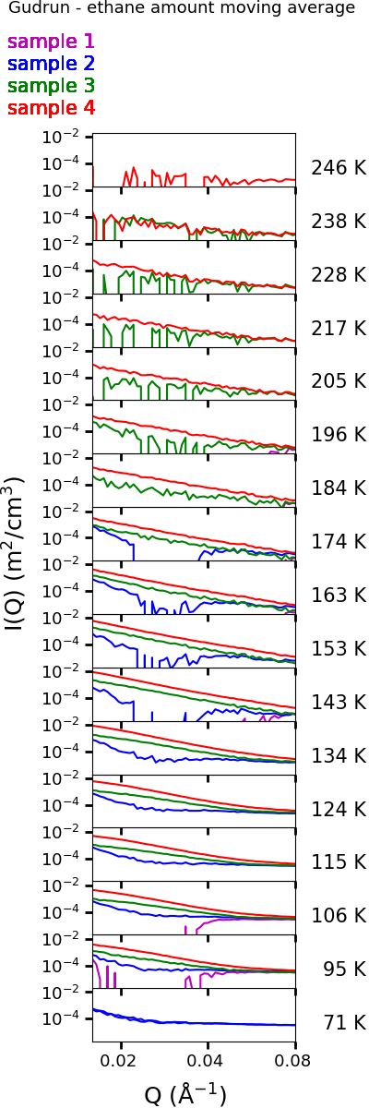

## d-Parameter

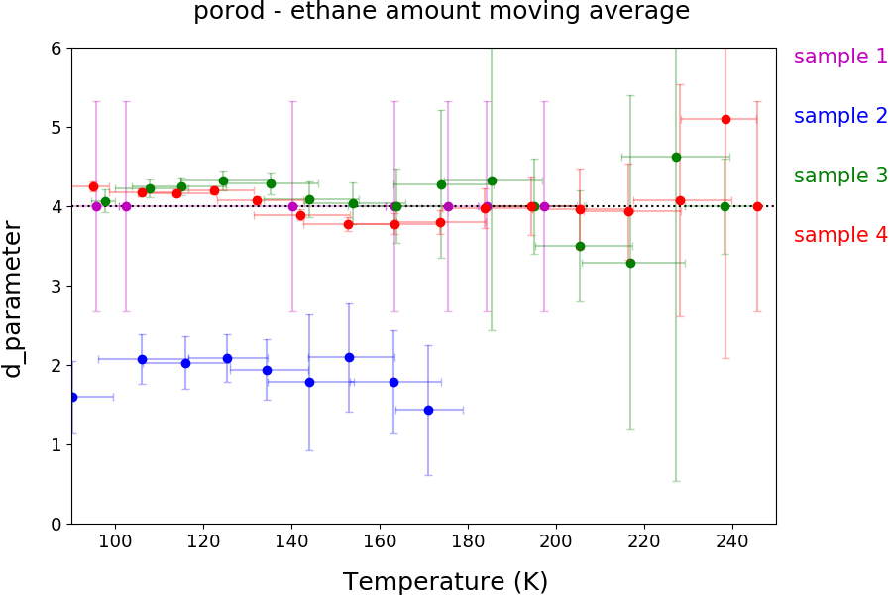

## SSA

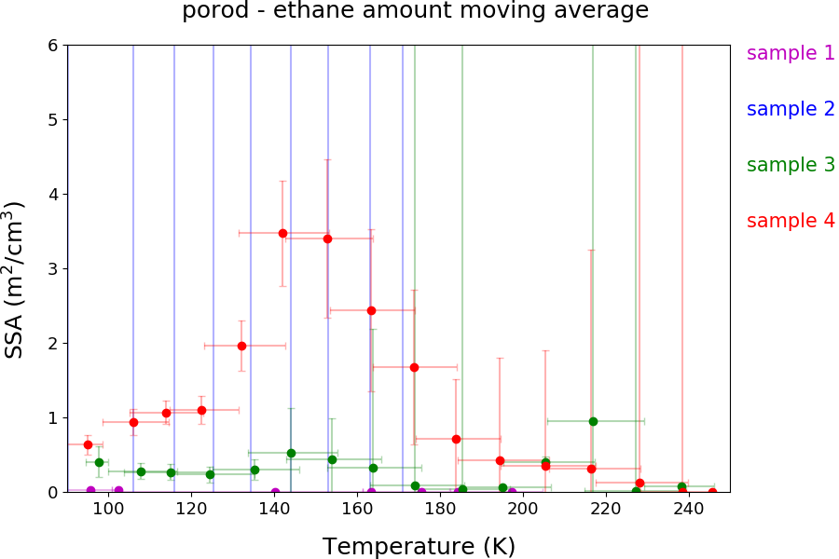

## Interpretation (samples 3 and 4 only)

At T > 140 K, the Porod exponent, d, drops to 4 or slightly below that, indicating smooth or slightly rough, sharp interfaces. At low T, it is above 4, indicating a contribution from diffuse interfaces.

The SSA at T > 140 K shows a similar trend to what we observed for the LN2 icy particles, at low T, this trend deviates. The SSA increases with T.

As ${\left(∆ρ_{CH}\right)}^{2}< {\left(∆ρ_{DH}\right)}^{2}< {\left(∆ρ_{DC}\right)}^{2}$, the main contribution at low T must be from C2H6 – He interfaces, which appear to be diffuse. (Interesting: When we freeze D2O in LN2, it has diffuse interfaces. When we freeze D2O in ethane, it has sharp interfaces (at least above 140 K). When we freeze ethane in LN2, it has diffuse interfaces.)

Comparison between samples 3 and 4 shows higher SSA for sample 4. As sample 4 was produced at a higher operation pressure of the aspirator, we would expect smaller particles and thus a higher SSA. So, the general trend makes sense, although an order of magnitude difference seems a bit extreme. However, the fitted value of d strongly influences the best fitting SSA. Within uncertainties, the d parameters match between the two samples, but sample 3 comes out at higher d. Overestimating d would result in underestimating SSA, so this would enhance the trend expected from the different production conditions.